Fall, 1999

CLASSⅡ Information Technology Engineer Examination - Morning

The examination conditions are as follows:
Question Nos. | Q1 to Q80
Question Selection | All questions are compulsory
Examination Time | 9:30-12:00 150 minutes
Notes:
1. Use an HB pencil.
If you need to change an answer, erase your previous answer completely and neatly. Wipe away any eraser fragments.
2. Mark your answers in accordance with the instructions below. Your test will not be graded if you fail to comply with the instructions. Do not mark or write on the answer sheet outside of the prescribed places.
(1) Examinee Number
Write your examinee number in the space provided, and mark the appropriate space below each digit.
(2) Date of Birth
Write your date of birth (in numbers) exactly as it is printed on your exam ticket, and mark the appropriate space below each digit.
(3) Answers
How to Mark Your Answers
Select one answer (A through D) for each question.
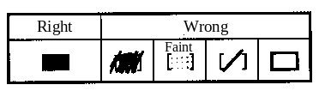
Mark your answer as shown in the following sample question.

[Sample Question] In which month is the Fall Information Technology Engineer Examination conducted?

A. 8 | B. 9 | C. 10 | D. 11

Since the correct answer is "C" (10), mark your answer sheet as follows:

Sample Question A B C D
Do not open the exam book until instructed to do so.
Inquiries about the exam questions will not be answered.

Q1. Which of the following decimal numbers would have an infinite number of bits when expressed in binary?

A. 0.05 | B. 0.125 | C. 0.375 | D. 0.5

Q2. What is the product of the hexadecimal number 0.FEDC multiplied by four?

A. 1.FDB8 | B. 2.FB78 | C. 3.FB70 | D. F.EDC0

Q3. How many digits would be required in order to express the greatest possible 14-digit hexadecimal number in decimal notation? Assume log₁₀2 = 0.301.

A. 15 | B. 16 | C. 17 | D. 18

Q4. How is the decimal number –5.625 expressed as an 8-bit fixed-point binary number? Assume that the binary point is located between bits 4 and 5, and that two's complement is used to represent negative numbers.

8 7 6 5 4 3 2 1
↑
Fixed point

A. 01001100 | B. 10100101 | C. 10100110 | D. 11010011

Q5. In a floating-point representation, which operation will ensure that the most significant digit of the absolute value of the mantissa is a non-zero number?

A. Round up | B. Truncate | C. Carry | D. Normalize

Q6. When performing addition and subtraction operations in a computer, it is important to be careful of overflow. Which of the operations described in the following table have the potential for generating an overflow condition?

 | Operation | Operand x | Operand y
a | x+y | Positive | Positive
b | x+y | Positive | Negative
c | x+y | Negative | Positive
d | x+y | Negative | Negative
e | X–y | Positive | Positive
f | x–y | Positive | Negative
g | x–y | Negative | Positive
h | x–y | Negative | Negative

A. a, d, f, g | B. b, c, e, h | C. b, e | D. c, e, h

Q7. Which of the following logical expressions is identical to? 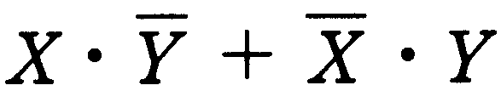 Assume that "•" represents the logical product, "+" represents the logical sum, and  represents the negated value of X.

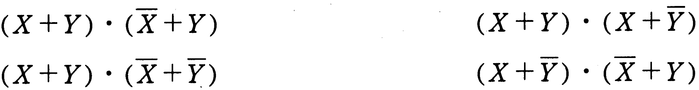
A.
B.
C.
D.

Q8. Assume two variables, x and y, that can take on the values "0" and "1". Which of the following expressions is equivalent to the condition 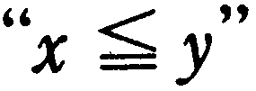 for all possible combinations of x and y? Assume that AND represents the logical product, OR represents the logical sum, and represents the negated value of A.
C.
A.
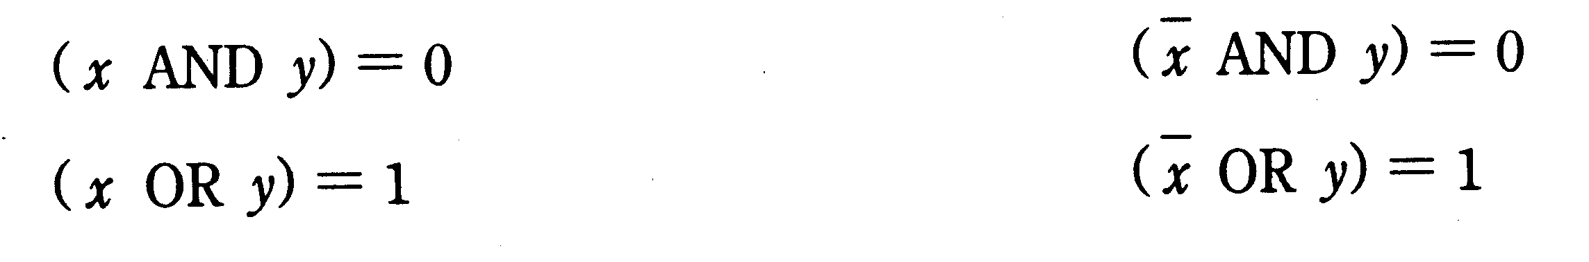
D.
B.

Q9. Given the circuit shown below, when each input value is D=1, E=0, F=1, which of the following is the correct combination of outputs P, Q, and R? Assume 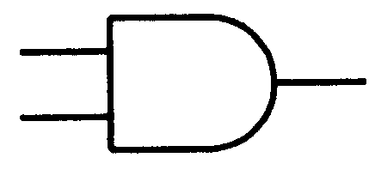 represents an AND gate, 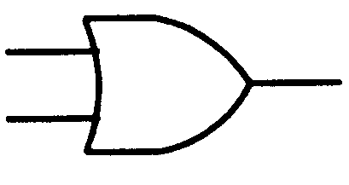 represents an OR gate, and 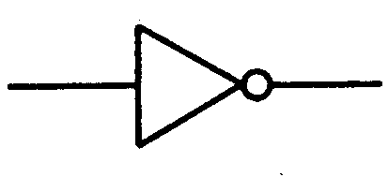 represents a NOT gate.
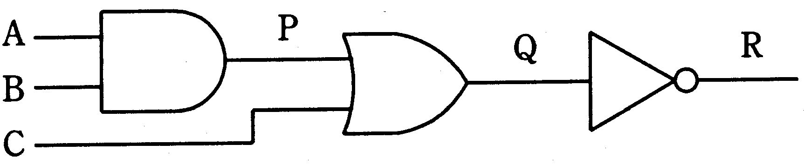
P
D
E
F
Q
R

 | P | Q | R
A. | 0 | 1 | 0
B. | 0 | 1 | 1
C. | 1 | 0 | 1
D. | 1 | 1 | 0

Q10. Which of the following is an appropriate definition of "rounding error?"

A. Error that is produced when the result of an operation exceeds the maximum value that a computer is capable of handling.
B. Error that is produced when the least significant digits in a numeric value are rounded off, rounded up or truncated due to a limit on the maximum number of digits that can be used in a numerical expression.
C. Error that is produced due to the loss of the most significant digits in an addition or subtraction operation involving values that have practically equal absolute values.
D. Error that is produced due to the loss of the less significant digits in the mantissa of the value with the smaller exponent in an addition or subtraction operation involving floating-point decimals.

Q11. If element 12 is removed from the binary search tree shown below, which element should be moved to the empty node in order to reform the binary search tree?
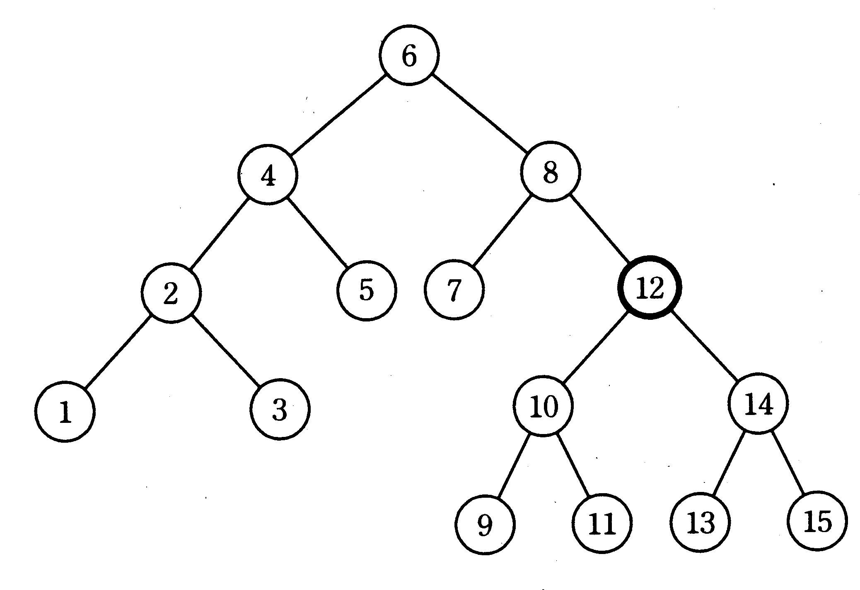

A. 9 | B. 10 | C. 13 | D. 14

Q12. If the number of elements in a binary search tree is quadrupled, what effect does this have on the maximum number of searches?

A. Increases the maximum number of searches by one
B. Increases the maximum number of searches by two
C. Approximately doubles the maximum number of searches
D. Approximately quadruples the maximum number of searches

Q13. Which data structure is appropriate for FIFO (First-In First-Out) processing?

A. Binary tree | B. Queue | C. Stack | D. Heap

Q14. Integers are stored in the first through Nth elements of array A (where N > 1). The flowchart below checks to see which element contains the value X. Which answer below describes the result obtained by executing this flowchart?
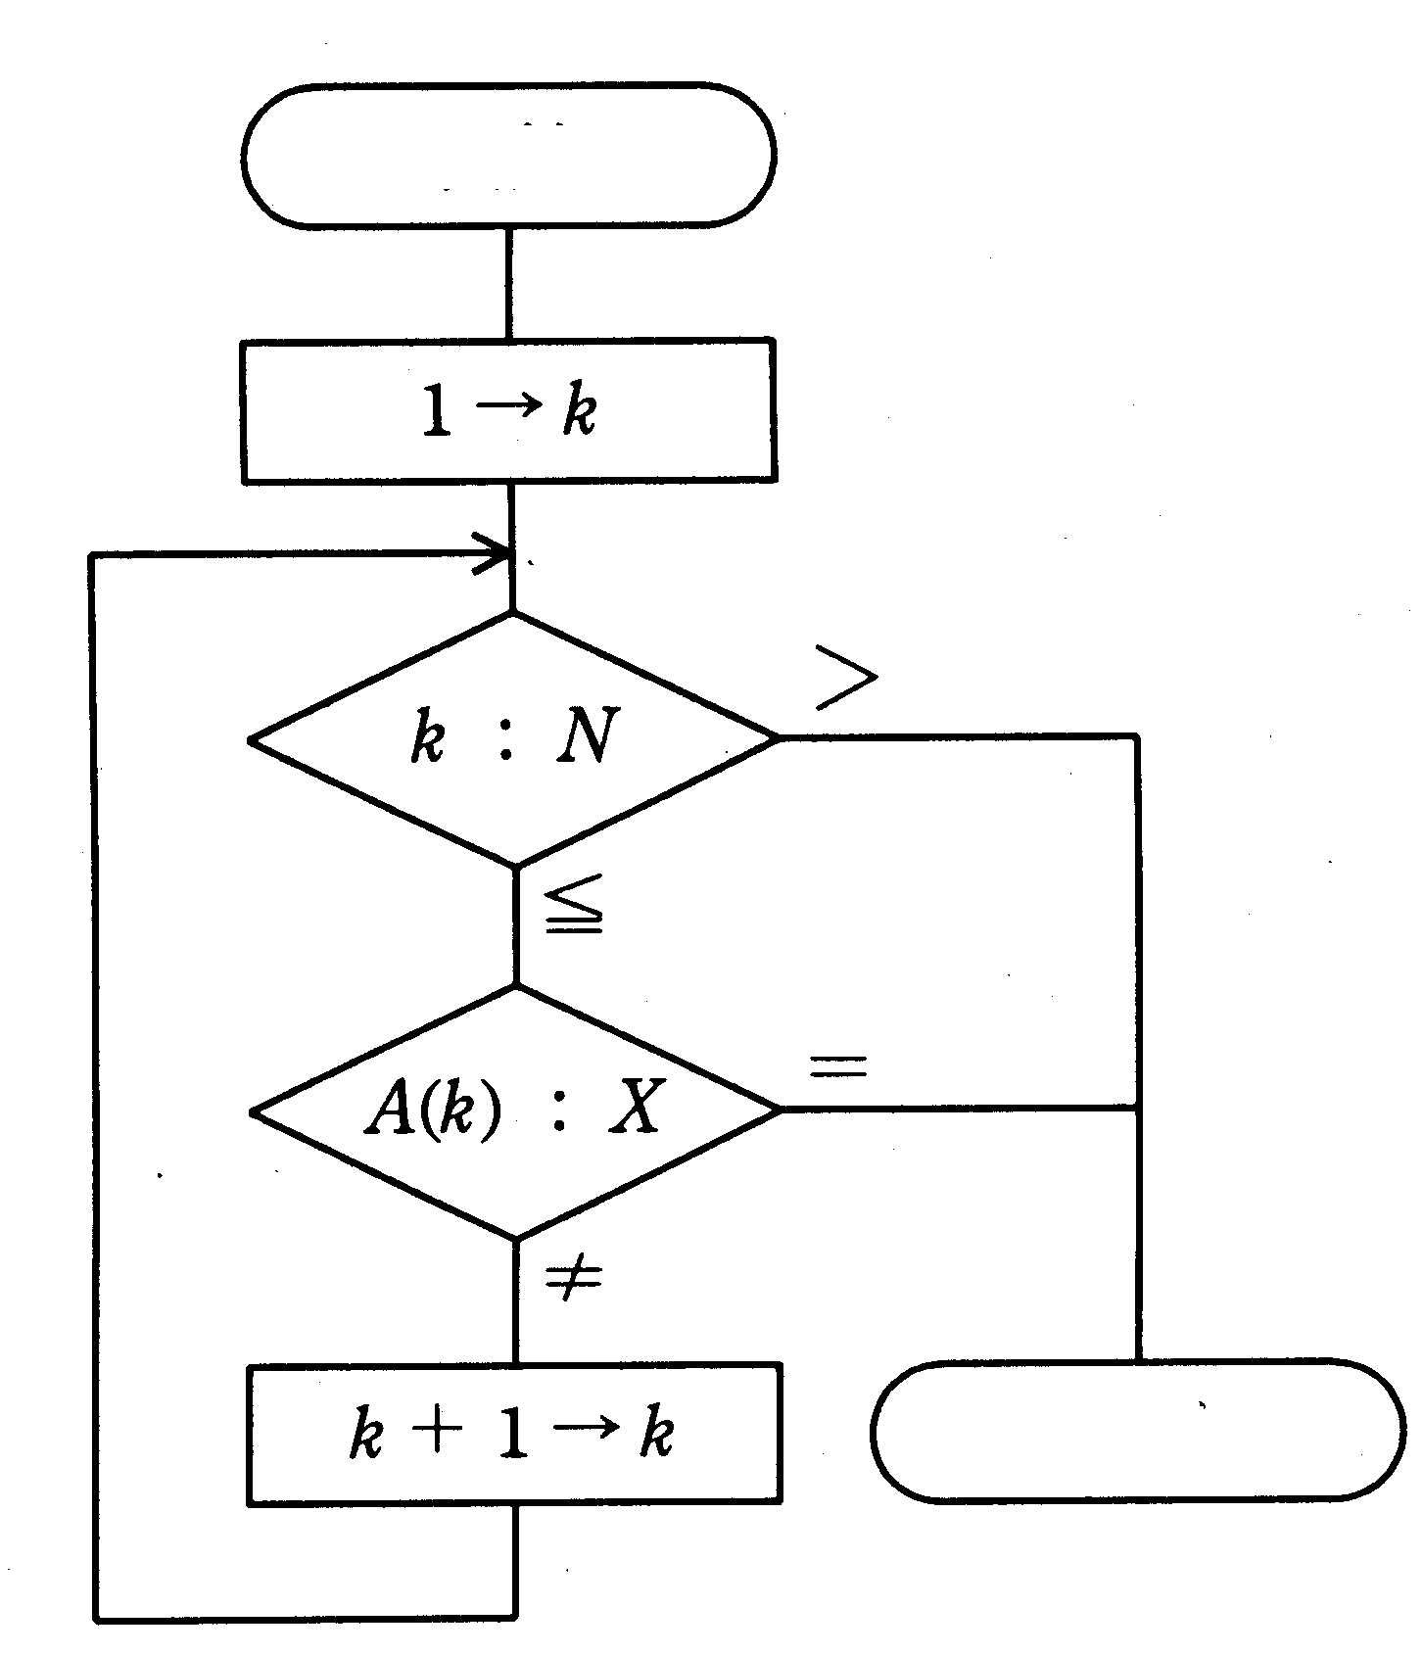
Start

End

A. If the value X does not exist in the array, "1" is stored in k.
B. If the value X does not exist in the array, N is stored in k.
C. If the value X exists in two elements, the first element and the Nth element, "1" is stored in k.
D. If the value X exists in two elements, the first element and the Nth element, N is stored in k.

Q15. What condition needs to be inserted in the blank space below so that the same value x is obtained as the result when each of the algorithms described in the two flowcharts below are performed on the positive integer M?
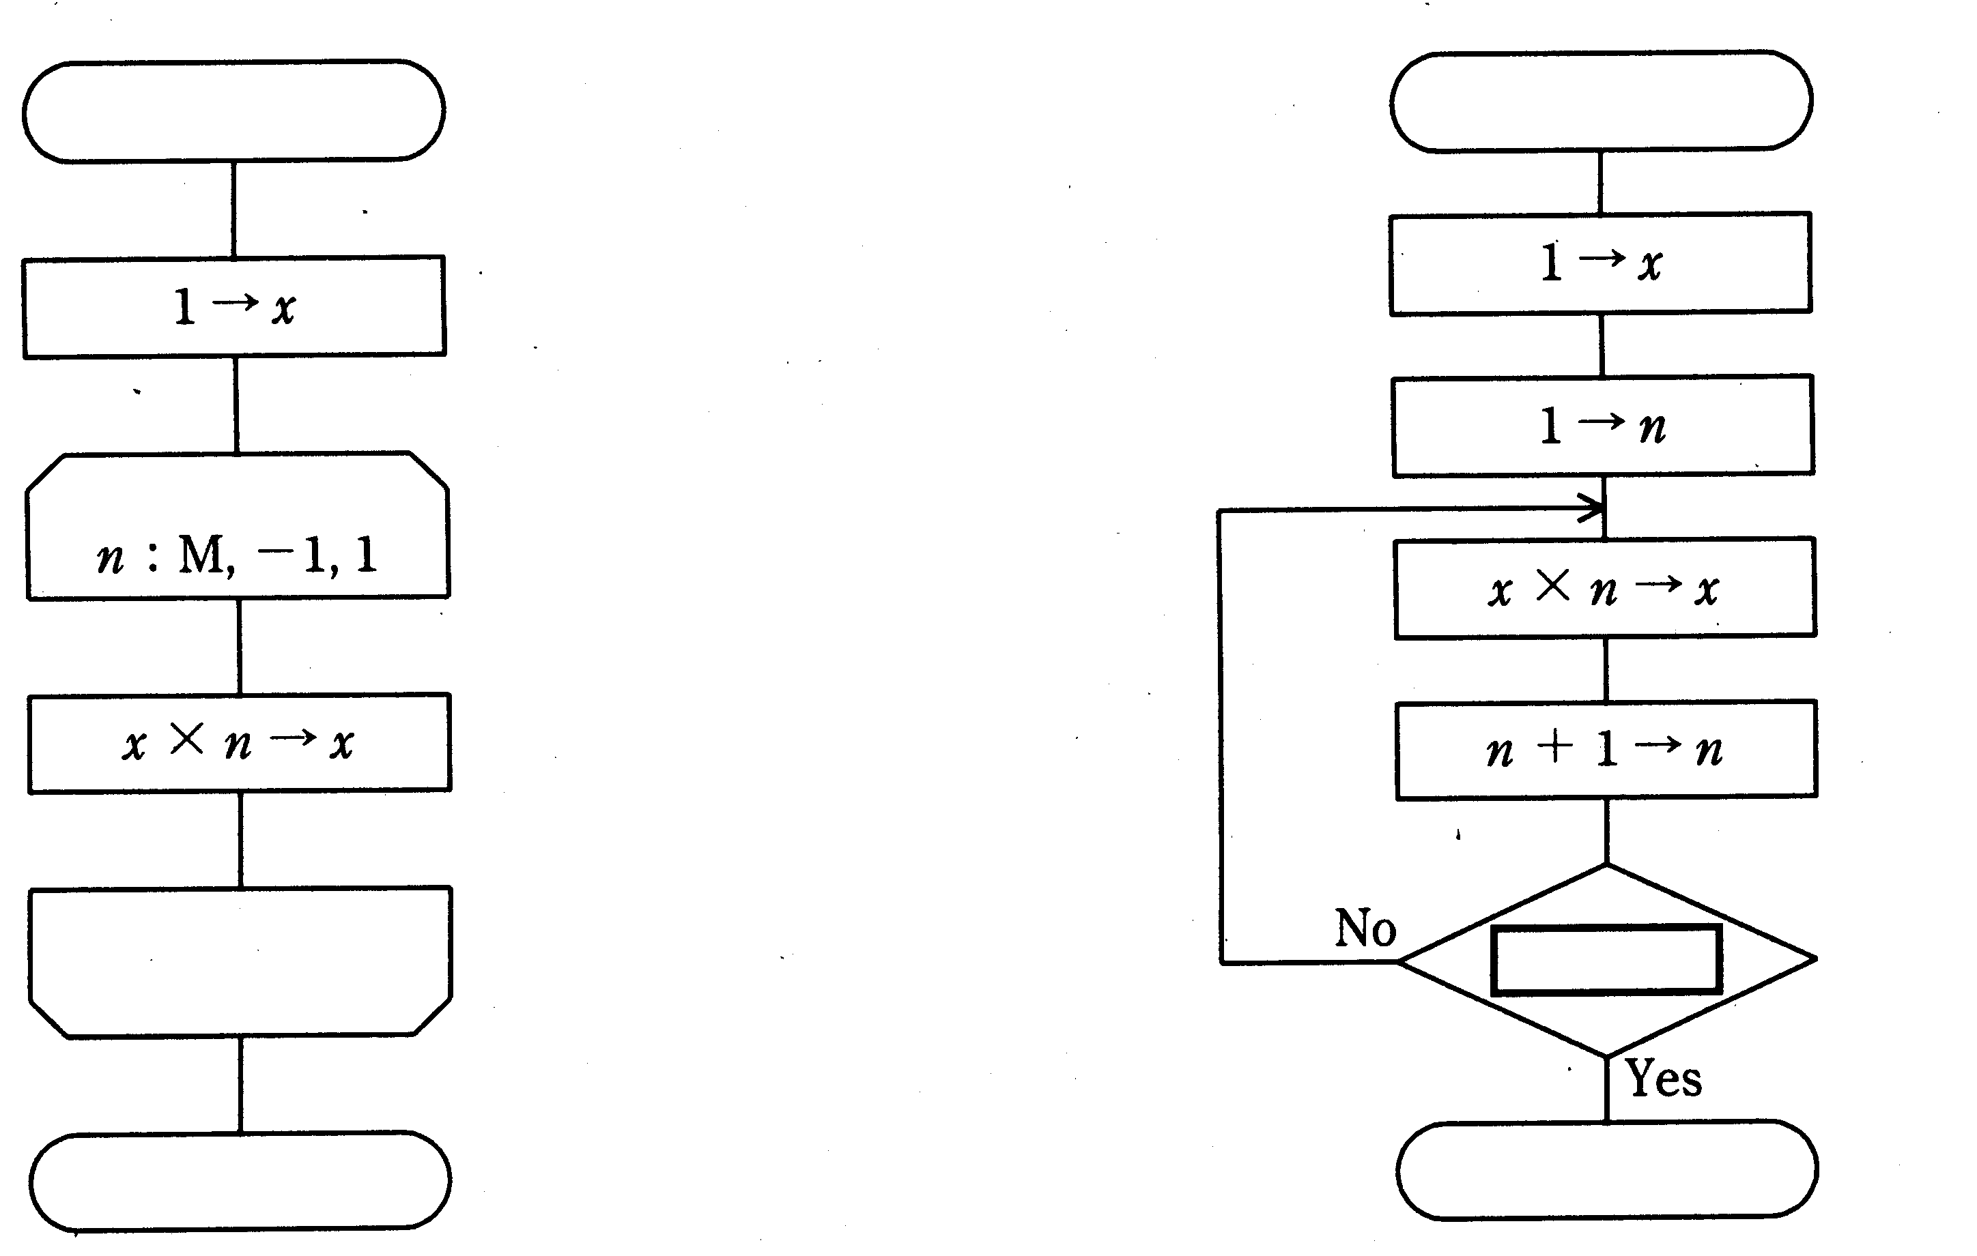
Start
Start

The loop conditions are given as:
variable name: initial value, increment, ending value
Operation

Operation

End
End

A. n > M | B. n > M + 1 | C. n > M — 1 | D. n < M

Q16. Which of the following error control methods for memory is used to provide functions for detecting two-bit errors and for correcting one-bit errors?

A. Odd parity | B. Horizontal parity
C. Checksum | D. Hamming code

Q17. Which of the following is a correct description of memory interleaving?
A. When new data is stored in cache memory, writing data in the cache that is no longer needed back to main memory.
B. Compensating for the gap in access time between main memory and a magnetic disk.
C. Updating main memory and cache memory simultaneously.
D. Dividing main memory into several partitions that can be accessed in parallel in order to perform consecutive memory accesses efficiently.

Q18. Which of the following execution control methods permits processing of multiple instructions in parallel by dividing the instruction execution cycle into several stages (instruction fetch, instruction decoding, operand address decoding, operand fetch, and execution) and then assigning separate devices to each stage of processing?

A. Data flow | B. Pipeline
C. Process | D. Microprogram

Q19. Which of the following combinations of CPU clock frequencies and CPI (Cycles Per Instruction) values shown in the table below will result in the shortest time required to execute a program containing a given number of instructions?

 | Clock frequency (MHz) | CPI
A. | 200 | 7
B. | 250 | 8
C. | 300 | 10
D. | 350 | 12

Q20. How long would it take a 50MIPS computer to process 30 million instructions? (Round to two digits.) Assume a processor duty ratio of 70%, and ignore OS overhead.

A. 0.42 | B. 0.60 | C. 0.86 | D. 1.17

Q21. The following figure depicts the access time for a hard disk drive. Select the correct combination of definitions for "a" through "d."
Controller issues read
write instruction
Read
write operation ends
Read
write operation begins
Access time
a
b
c

d

 | a | b | c | d
A. | Seek time | Search time | Wait time | Data transfer time
B. | Seek time | Wait time | Search time | Data transfer time
C. | Wait time | Seek time | Data transfer time | Search time
D. | Wait time | Data transfer time | Seek time | Search time

Q22. Assume a magnetic disk drive with 1,200 bytes per sector. When storing a file that has a fixed logical record length of 900 bytes on this drive, what blocking factor would result in the most efficient use of disk space? Ignore control information such as block control information.

A. 3 | B. 4 | C. 5 | D. 6

Q23. Assume a magnetic disk drive with the specifications shown in the table below. If this magnetic disk drive is formatted with 20 sectors per track and 1,024 bytes per sector, what will be the capacity of the drive, in megabytes? Assume 1k bytes=1,024 bytes, 1M bytes=1,024k bytes.

Number of tracks per cylinder | 23
Number of cylinders | 800

A. 313 | B. 360 | C. 368 | D. 378

Q24. Assume a magnetic disk drive with the specifications shown in the table below. How long (in milliseconds) is the access time needed to read one block (5,000 bytes) of data from this disk drive?

Rotational speed of disk | 2,500 rpm
Storage capacity per track | 20,000 bytes
Average seek time | 25 ms

A. 31 | B. 37 | C. 43 | D. 50

Q25. A magnetic disk drive head is currently positioned at cylinder 100, and the input/output request queue currently contains requests for cylinders 120, 90, 70, 80, 140, 110, and 60. Given the conditions listed below, what is the total number of cylinders the head must move?

[Conditions]
(1) The seek optimization method that is in use re-orders the I/O requests so that the head moves in only one direction as much as possible, so that the cylinders are processed in order.
(2) Up to the current request, the head had been moving in the direction of increasing cylinder numbers.
(3) If there is no request in the current direction, the head changes direction.
(4) Changing the order of the requests has no impact on the results.
(5) New requests are not generated while processing is in progress.

A. 80 | B. 120 | C. 160 | D. 220

Q26. Which of the following is an appropriate definition of "flash memory?"

A. Flash memory does not require any processing to retain the data that is currently stored; because data can be retrieved quickly, this type of memory is frequently used for cache memory.
B. Flash memory can be completely erased by exposure to ultraviolet light and then rewritten.
C. Flash memory is commonly used for main memory, and must be constantly refreshed in order to retain its contents. Flash memory permits high integration, and has a low cost per unit of storage.
D. Flash memory requires no backup power supply, and can be partially or completely erased electronically and then rewritten.

Q27. Which of the following media has the largest storage capacity per disk?

A. CD-R | B. DVD-RAM | C. FD | D. MO

Q28. Which combination of interfaces permits the connection of the following peripheral devices to a personal computer? ATA/ATAPI-4 is frequently referred to as "IDE."

 | Hard disk,  CD-ROM | Modem | Keyboard
A. | ATA/ATAPI-4 | GPIB | SCSI
B. | GPIB | SCSI | RS-232C
C. | SCSI | RS-232C | USB
D. | USB | IrDA | ATA/ATAPI-4

Q29. Which of the following is an appropriate definition of a "thermal transfer printer?"

A. A printer that prints by directly spraying ink onto the print media.
B. A printer that prints by using laser light to create an image on a photosensitive drum coated with a photoconductive material, and then transfers toner that adheres to the drum onto a sheet of paper.
C. A printer that prints by placing a film coated with a sublimating dye on paper coated with a polyester resin, and then using heat from the print head to sublimate the ink film dye onto the paper.
D. A printer that prints by using a thermal head containing a row of several tiny heating elements to apply heat to paper that changes color when heated.

Q30. Which of the following is a coordinate scanning device that is designed to input positional data in two or three dimensions to a computer, and which is used to input CAD drawings and to create NC (Numerical Control) machine tool data?

A. OCR | B. XY plotter
C. Digitizer | D. Light pen

Q31. There is one virtual memory system that divides the virtual address space into areas of a fixed length. Which of the following terms is the word for this fixed-length area?

A. Sector | B. Segment | C. Frame | D. Page

Q32. What is the purpose of task management in an OS?

A. Providing a command-based interactive interface for the operator.
B. Efficient implementation of virtual storage.
C. Performing control functions in order to use the processor more efficiently.
D. To permit the processing of data without needing to be aware of the hardware.

Q33. The following figure shows the states and transitions of a process. Which is the correct combination of a, b, and c?

Causes of state transitions
a
b
c
①
②
③
④
① CPU usage authority was transferred to a process with a high execution priority.
② CPU usage authority was received.
③ Waiting for completion of an input/output operation.
④ Input/output operation was completed.

 | a | b | c
A | Ready state | Active state | Wait state
B | Ready state | Wait state | Active state
C | Active state | Ready state | Wait state
D | Active state | Wait state | Ready state

Q34. Which of the following is applicable to "multiprogramming?"

A. Although multiple jobs are processed, they are executed as single tasks.
B. Other tasks are executed in parallel with a given task by utilizing idle CPU time that arises when performing I/O, etc.
C. It is a programming method in which a program calls itself while it is running.
D. It entails processing of programs in parallel and requires a parallel processing system that couples multiple processors and memory.

Q35. Which of the following is an appropriate definition of a "recursive program?"

A. A program that can call itself.
B. A program that can be located and executed from anywhere in main memory.
C. A program that can be called and processed correctly by multiple tasks.
D. A program that can be repeatedly executed without being reloaded.

Q36. Which of the following is applicable to "dynamic link library (DLL)?"

A. It is compiled by the compiler.
B. It is created by the pre-compiler before compiling.
C. It is linked by the OS before execution.
D. It is linked and compiled by the linker when the load module is created.

Q37. After creating a source program in COBOL or C, what is the proper combination of software that should be inserted for "a" through "c" in order to execute the program in the procedure illustrated below?
Source program
Object program
a
b

Load module
Execution
c

 | a | b | c
A | Compiler | Linker | Loader
B | Compiler | Loader | Linker
C | Linker | Compiler | Loader
D | Linker | Loader | Compiler

Q38. If the method of executing a Java or other byte code program through an interpreter and the method of first compiling and then executing the program are compared according to the conditions listed below, what is the (rough) minimum number of lines of byte code required in order for the compiling method to result in a shorter processing time than the interpreter method?

[Conditions]
1) The execution time is proportional to the number of lines in the program.
2) If a 100-line byte code program is executed through the interpreter, it takes 0.2 seconds, but if the same program is first compiled and then executed, it takes 0.003 seconds.
3) The compile time per 100 lines is 0.1 seconds.
4) When the compile method is used, regardless of file input/output and compiler startup always entails 0.15 seconds of overhead,.
5) Ignore all other time, such as the time needed for downloading the program files, etc.

A. 50 | B. 75 | C. 155 | D. 225

Q39. What is the result produced by executing the following program? Assume parameter x as a call by value; assume parameter y as a call by reference.

Main program |  | Subprogram sub(x, y)
a=3; |  | x=x+y;
b=2; |  | y=x+y;
sub(a,b); |  | return;

A. a=3, b=2 | B. a=3, b=7 | C. a=5, b=2 | D. a=5, b=7

Q40. In a frame transferred by a high-level data link control protocol (HDLC protocol), which field is used for error detection?

F | A | C | I | FCS | F

A. A | B. C | C. FCS | D. I

Q41. Which of the following properly describes the relationship between the TCP and IP protocols used on the Internet and the seven layers of the OSI basic reference model?

TrTransport layer  Network layer  Datalink layer |  | A. |  | B. |  | C. |  | D.
TrTransport layer  Network layer  Datalink layer |  | IP |  |  |  | TCP
TrTransport layer  Network layer  Datalink layer |  | TCP |  | IP |  | IP |  | TCP
TrTransport layer  Network layer  Datalink layer |  |  |  | TCP |  |  |  | IP

Q42. In a data transfer using start-stop synchronization with even parity used for character detection, the character "T" (JIS 7 bit code string 1010100) is sent. What is the bit string when this character is received correctly? The transmitted data consists of the start bit (0), the data bits (LSB first), the parity bit, and the stop bit (1). The received bits are written in order, starting from the left.

A. 0001010101 | B. 0001010111 | C. 1001010110 | D. 1001010111

Q43. Which of the following values is closest to the line usage rate (%) when transferring files that average 1,000 bytes in length at even intervals 0.6 times per second between terminals connected by a 64kbps dedicated line? Assume that control information equivalent to 15% of the amount of data being transferred is added to each file transfer.

A. 1.1 | B. 7.5 | C. 8.6 | D. 24.0

Q44. Which of the following is applicable to a "router?"

A. It handles connections in the data link layer and has a traffic isolation function.
B. It performs protocol conversion, including protocols in and above the transport layer, mutually connecting networks that have different network architectures.
C. It handles connections in the network layer, and is used to connect LANs, etc., through a wide area network.
D. It handles connections in the physical layer, and is used to extend the connection distance.

Q45. Which of the following LAN access methods permits multiple terminals to send data simultaneously, making it possible for transmission conflicts to occur?

A. ATM |  | B. CSMA/CD
C. FDDI |  | D. Token ring

Q46. Which of the following is applicable to indexed file organization, a type of file organization method?

A. It permits direct access of records according to the address of each record. May have an adverse effect on the efficiency with which a media is used.
B. It keeps track of records in the order in which they were written. Only permits sequential access.
C. It consists of data areas, called "members," and a registration area for managing member information. This method is suitable for program storage.
D. It consists of an area where records are written, and an area where record key information is written.

Q47. There are two primary types of files that are used to recover a data base if a media fault occurs. One is a backup file. What is the other?

A. Transaction file |  | B. Master file
C. Rollback file |  | D. Log file

Q48. Which of the following data models is used in the conceptual design of data bases, and expresses its target world through the two notions of “entities” and “relationships between two entities”?

A. E-R model |  | B. Hierarchical model
C. Relational model |  | D. Network model

Q49. Which of the following is applicable to a three-level schema structure for data bases?

A. A conceptual schema expresses physical relationships between data.
B. An external schema expresses a view of data required by the user.
C. An internal schema expresses logical relationships between data.
D. A physical schema expresses physical relationships between data.

Q50. Which of the following is an appropriate definition of domains used in relational data bases?

A. Relations that are derived from basic relations using relational operations.
B. A method of projecting the real world into a data base.
C. The set of the values an attribute can take.
D. A generic term for inserting, updating, deleting, and searching data in a data base.

Q51. Given the "Products" table shown below, what will be the results produced by the following SQL statement?

SELECT product number FROM product
WHERE product name LIKE "%noodles"
AND unit price < 330

Products
Product number | Product name | Unit price
100 | Ramen | 305
130 | Kishimen | 285
205 | Chashumen | 700
267 | Okameudon | 300
307 | Happomen | 350
390 | Curry rice | 400
401 | Chahan | 320
420 | Kitsune udon | 298

A. | Product number | B. | Product number | C. | Product number | D. | Product number
 | 100 |  | 100 |  | 130 |  | 130
 | 130 |  | 130 |  |  |  | 267
 |  |  | 267
 |  |  | 420

Q52. What is the term for the time from the point when an inquiry or a request has just been issued to a computer system until the point when the message indicating the results of that processing first appears on the user's terminal?

A. Access time |  | B. Cycle time
C. Turnaround time |  | D. Response time

Q53. Which of the following is a suitable description concerning the evaluation of system performance?

A. In OLTP(Online Transaction Processing), the MIPS value is used to evaluate system performance.
B. Response time and turnaround time are indicators of system performance from the viewpoint of a system administrator.
C. Generally, the higher the usage of system resources is, the better the response time is.
D. The number of transactions or jobs that can be processed in a given unit of time is important for evaluating system performance.

Q54. The following table lists the monthly operating time and the repair time for a device over a period of ten months. Which combination shown below indicates the correct MTBF, MTTR, and operating ratio for this device? Assume only one repair per month.

Month | Operating time | Repair time
1 | 100 | 1
2 | 200 | 1
3 | 100 | 2
4 | 100 | 2
5 | 200 | 2
6 | 200 | 1
7 | 200 | 1
8 | 100 | 1
9 | 100 | 2
10 | 200 | 2

 | MTBF | MTTR | Operating ratio
A | 1.5 | 150.0 | 0.91
B | 15.0 | 150.0 | 0.91
C | 150.0 | 1.5 | 0.99
D | 1,500.0 | 15.0 | 0.99

Q55. Which of the following is the most suitable description of a centralized processing system when compared with a distributed processing system?

A. Because recovery work can be performed in a centralized fashion at the computing center in the event of a disaster or failure, a centralized processing system avoids the danger of extended system downtime.
B. Because management of the system is centralized, it is easy to respond to requests for additions or changes to system functions, and it is difficult for a backlog to accumulate.
C. By focusing such measures primarily on the computer center, maintaining and managing security and the consistency of data is easy.
D. Although the operation and management of hardware and software resources is difficult, expansion in response to new technology is easy.

Q56. Which of the following statements is applicable to "prototyping," a method of software development?

A. Because work proceeds sequentially through basic plan, outline design, detail design, program design, programming, and testing, it is possible to get a good overview of the entire project and it is easy to determine the schedule and allocate resources.
B. Because a prototype is created at an early stage of system development, it is possible to eliminate vagueness and differences of perception between the user department and the developing department.
C. The characteristics of the software are divided into those for which the specifications are fixed and do not require changing and those for which the specifications require changing, and then the process of creating, reviewing and changing those specifications is repeated.
D. A large application is divided into highly independent sections; each section then undergoes a process of design, programming and testing over and over, gradually expanding the scope of development of the program.

Q57. The weaker that module linking (a measurement of module independence) is, the greater the independence of a module. Which of the following levels of module linking reflects the highest module independence?

A. Shared linking | B. Stamp linking | C. Data linking | D. Content linking

Q58. A program that accepts individual forms for updates to basic salary, updates to benefits, and updates to exemptions and then updates the file used to calculate pay is divided into the modules shown in the diagram below. What is this type of module division called?
File updating

Basic salary updating
Benefits updating
Exemptions updating

A. STS division method | B. Jackson method
C. Transaction decomposition | D. Warnier method

Q59. Which check should be performed after the following order data has been input in order to detect whether the order date is a work day that is the same day as or before the input date?

Order data
Invoice number  (text) | Order date  (text) | Product code  (text) | Quantity  (numeric) | Customer code  (text)

A. Duplicate check | B. Numeric check | C. Format check | D. Logic check

Q60. There is a method of detecting input errors from just the input data by adding the result obtained by a calculation such as the “modulus 11” algorithm to the end of a product code, etc. What is the term for this item that is added to the end of a data element?

A. Digit code | B. Check digit | C. Check point | D. Decimal code

Q61. Which software testing method is used in order to determine whether a change made for the sake of software maintenance has any effect on any other part of the program?

A. Operation test | B. Linking test | C. System test | D. Regression test

Q62. Which debugging method writes the contents of variables and registers each time that a specific instruction is executed?

A. Walkthrough | B. Snapshot | C. Test data generator | D. Driver

Q63. Which of the following is applicable to "top-down testing?"

A. It requires the creation of drivers to substitute for lower modules.
B. Because it is used for testing important higher modules, the reliability of higher modules increases.
C. At the end of testing, problems commonly occur in the interfaces between modules.
D. Because development begins with the higher levels where modules are less numerous, programming and testing can be performed in parallel from the start of development.

Q64. Which of the following statements is applicable to the role of stubs that are used in link testing?

A. They are linked in place of modules upon the completion of testing.
B. They return values in accordance with conditions from instructions that are called from the module that is the subject of testing.
C. They automatically generate test data in accordance with conditions from instructions that are called from the module that is the subject of testing.
D. They are called by instructions that call the module that is the subject of testing.

Q65. The following profit-loss statement was generated during the end of the quarter closing of the books. How many millions of yen of profit were earned from operations in the quarter?

Unit: Millions of yen
Item | Amount
Sales | 1,500
Cost of sales | 1,000
Marketing and general  administrative expenses | 200
Non-operating income | 40
Non-operating expenditures | 30

A. 270 | B. 300 | C. 310 | D. 500

Q66. A system development project plan was created using PERT, and the critical path was calculated. What is the appropriate way to use the critical path?

A. To understand which jobs should be given the most attention from the standpoint of the quality of the system.
B. To understand which jobs can be performed in a different sequence.
C. To understand which jobs are directly connected to delays in the overall project.
D. To understand which jobs will generate the most costs.

Q67. In the schedule plan shown below, what is the latest day on which job E can begin?
B
③
A
E
G
D
①
②
⑤
⑥
C
F
④

Job | Target number of days
A  B  C  D  E  F  G | 3  6  5  3  4  5  3

A. 7 | B. 9 | C. 12 | D. 13

Q68. Which of the following statements is applicable to inventory management based on ABC analysis?

A. It is best to decide the ordering points beforehand for groups A, B, and C on the basis of statistics and probability.
B. It is best to manage individual items in group A very closely, since group A represents items which are small in number but carry a high inventory cost.
C. It is best to manage individual items in group B very loosely, since group B represents items which are large in number but carry a low inventory cost.
D. It is best to decide ordering volumes for group C after studying requirements and inventory levels on a regular basis.
Q69. Which of the following is appropriate for a management chart that clarifies a vague awareness of problems, organizes and summarizes elements that could be contributing factors to such problems, and helps to identify the essential and true causes of such problems?

A. Scatter diagram | B. Cause and effect diagram | C. Pareto diagram | D. Histogram

Q70. When creating a model of reception work and simulating the waiting situation, what type of distribution is used as the probability distribution for the number of occurrences of random phenomena, such as the number of people who arrive within a given unit of time?

A. Uniform distribution | B. Normal distribution
C. Binomial distribution | D. Poisson distribution

Q71. When one card is drawn from a deck of 52 cards (no joker), what is the probability that the card will be the Queen of Spades or a heart?

A. 1/208 | B. 1/26 | C. 1/4 | D. 7/26

Q72. Three products, A, B, and C, are processed o n two machines, M1 and M2. The processing must be performed in the sequence M1 → M2. The table below shows the amount of time required to process each product on each machine.
In what order should the three products be processed so that the time from the start of processing to the end of processing is the shortest?

Machine  Product | M1 | M2
A | 7 | 3
B | 5 | 6
C | 4 | 2

A. A → B → C |  | B. A → C → B
C. B → A → C |  | D. B → C → A

Q73. The table below shows a breakdown of sales for each of three sales managers (A, B, C) to each of three customers (x, y, z). For example, sales manager A can sell 2 million yen of goods to customer x. If each sales manager can only be responsible for selling to one customer, what is the maximum amount of sales possible?

Unit: millions of yen
 |  | Sales manager
 |  | A | B | C
Customer | x | 2 | 5 | 7
Customer | y | 4 | 3 | 8
Customer | z | 5 | 6 | 6

A. 16 | B. 17 | C. 18 | D. 19

Q74. Which of the following is an appropriate description of SGML?

A. A generic term for the standardization of CAD data being promoted in ISO-10303.
B. A typesetting system developed by Professor Knuth of Stanford University.
C. A language for describing hypertext, currently based on standardization eating home pages on the Internet.
D. A markup language that emphasizes describing the structure of text, standardized under ISO, and used for document transfers between computers.

Q75. The following diagram depicts an electronic signature verification system using public key cryptosystem. Which combination of keys is appropriate for a and b?
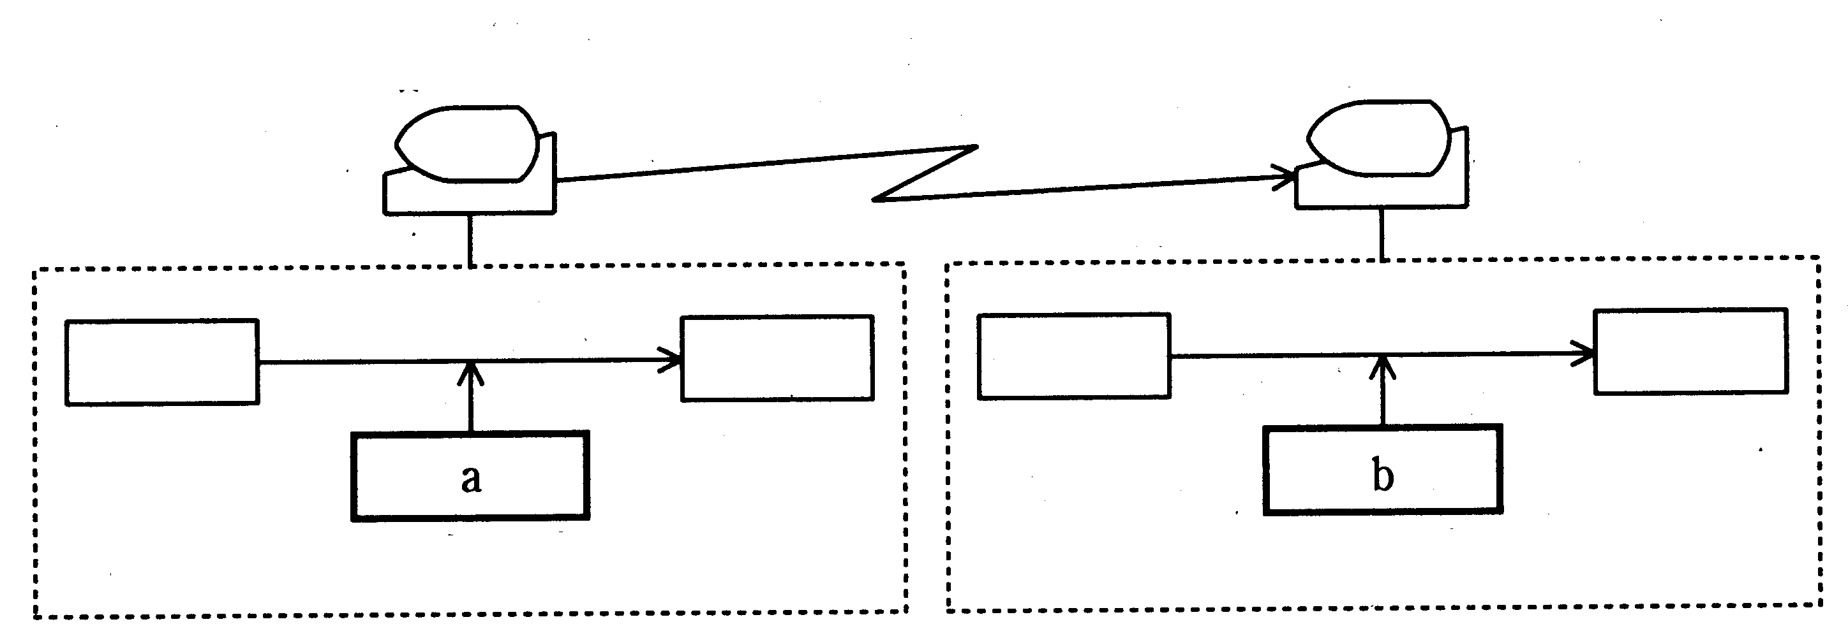
Sender
Receiver

Signature generation
Signature Detection
Text
Text
Signature
Signature

Generation key
Detection key

 | a | b
A | Receiver's public key | Receiver's secret key
B | Sender's public key | Sender's secret key
C | Sender's secret key | Receiver's public key
D | Sender's secret key | Sender's public key

Q76. Which of the following statements is applicable to macro viruses?

A. Although they have the ability to infect a system regardless of the OS that the system is running, they do not infect applications that are running in a Japanese-language environment.
B. Because they infect systems through the Internet, a personal computer that is not connected to the Internet cannot become infected.
C. An e-mail attachment cannot be used to infect a system.
D. Because macro viruses infect systems through data files, not program files, the virus can spread rapidly.

Q77. Which of the following terms is correct for data that is granted to a users for the purpose of checking the validity of a user's authorization to use a computer system and to see the usage of the system?

A. IP address | B. Access authority | C. Password | D. User ID

Q78. Which of the following correctly describes the period of protection for individual copyrighted works?

A. 25 years from the time of creation
B. 50 years from the time of creation
C. From the time of creation until 25 years after the author's death
D. From the time of creation until 50 years after the author's death
Q79. Which of the following is an appropriate description of a "radar chart?"

A. A radar chart graphically represents the relationship of fixed costs and variable costs to sales, and is used to analyze the break-even point.
B. A radar chart is a graph that resembles a spider web, and is used to see the balance between multiple characteristics.
C. A radar chart is used to judge the correlation between two characteristics, based on the scattering of points plotted on the graph.
D. A radar chart is a graph of monthly performance, cumulative performance, and the moving total, and is used to analyze trends in sales performance, etc., over a fixed period.

Q80. Which of the following statements is applicable to the creation of presentation materials?

A. Since bullet lists are an effective means of expressing information, use bullet lists to convey important information whenever possible.
B. Because a presentation is intended for you to express your own opinions to others, use subjective descriptions as much as possible.
C. Because diagrams are easily misunderstood, it is best to mostly use text, and only use figures and graphs in a supplementary role.
D. If you use periods in your text, you should use periods in your bullet lists.

